Lecture 7 – Deterministic Finite Automata

Automata:

* Read from an input device
* Move between various states
* Different types of automata exist
* Some have access to more than just states
  + Stack
  + Memory

Example of an automata:

* Alphabet is {0,1}
* A language that consists of only one word "01"
* The double circle at the end means accepts. **Not the same as finish,** just means an accepted state

Rules for automata:

* States represented graphically as circles
  + Sometimes labelled with descriptions, but usually not
* Transitions represented as arrows
  + Labelled with letters that trigger those transitions
  + Can sometimes be labelled with Ɛ, more on that later
* Start state represented with an arrow pointing into it
* End states represented with double circles, can be multiple

Another example:

* Alphabet is {0, 1}
* A language that consists of all words that begin with 0

Another example:

* Alphabet is {0,1}
* A language that consists of all binary numbers divisible by 4
* All binary numbers divisible by 4 end in 00 (because 00 at the end indicate 1 and 2, which either way would make it impossible to do anything with)

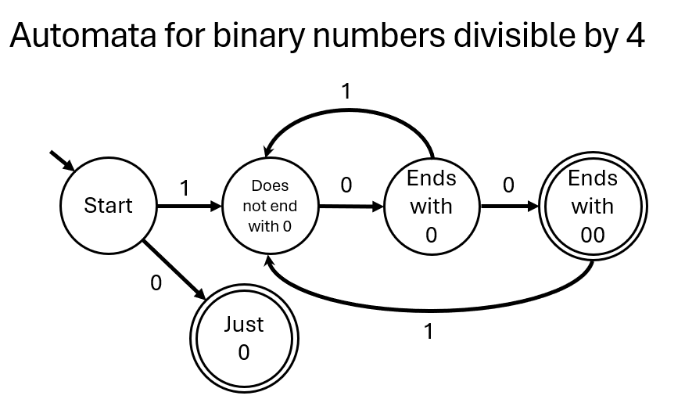

Another example:

* Alphabet is {A, B}
* A language that consists only of words A and AB
* Essentially the language of the (A | AB) regular expression

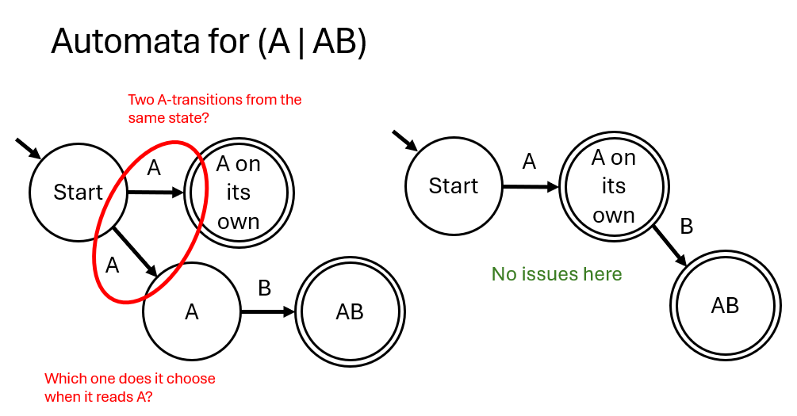

Deterministic and non-deterministic automata:

* An automata is deterministic if each state only has one transition for each character
* An automata is non-deterministic if repeated transitions exist

Complete and incomplete automata:

* A complete automata defines transitions for each character from each state
* This often creates the need for additional rejection states and more complicated graphical representations
* We often omit these extra transitions in graphical representations, but they all technically still exist in DFA

Alternative automata for 01:

